Regulatory Reporting System for Financial Institutions

Background
Financial Institutions are required to submit periodic regulatory reports to the relevant regulatory authority in accordance with applicable reporting standards and requirements. The development of the regulatory reporting system is based on user requirements and data mapping to ensure accurate and consistent reporting.

Project Objectives
The project involved the development of a regulatory reporting system for Financial Institutions to support monthly reporting to the relevant regulatory authority. The system was designed based on business requirements and data mapping to facilitate accurate, consistent, and standardized regulatory reporting.

Approach
The project followed a requirements driven approach, focusing on gathering business requirements, analyzing regulatory reporting needs, mapping source data to regulatory report fields.

Business Process Flow
The process covers the end-to-end regulatory reporting workflow, from data collection and completeness validation to report generation, format validation, approval, and submission through the regulatory reporting platform.

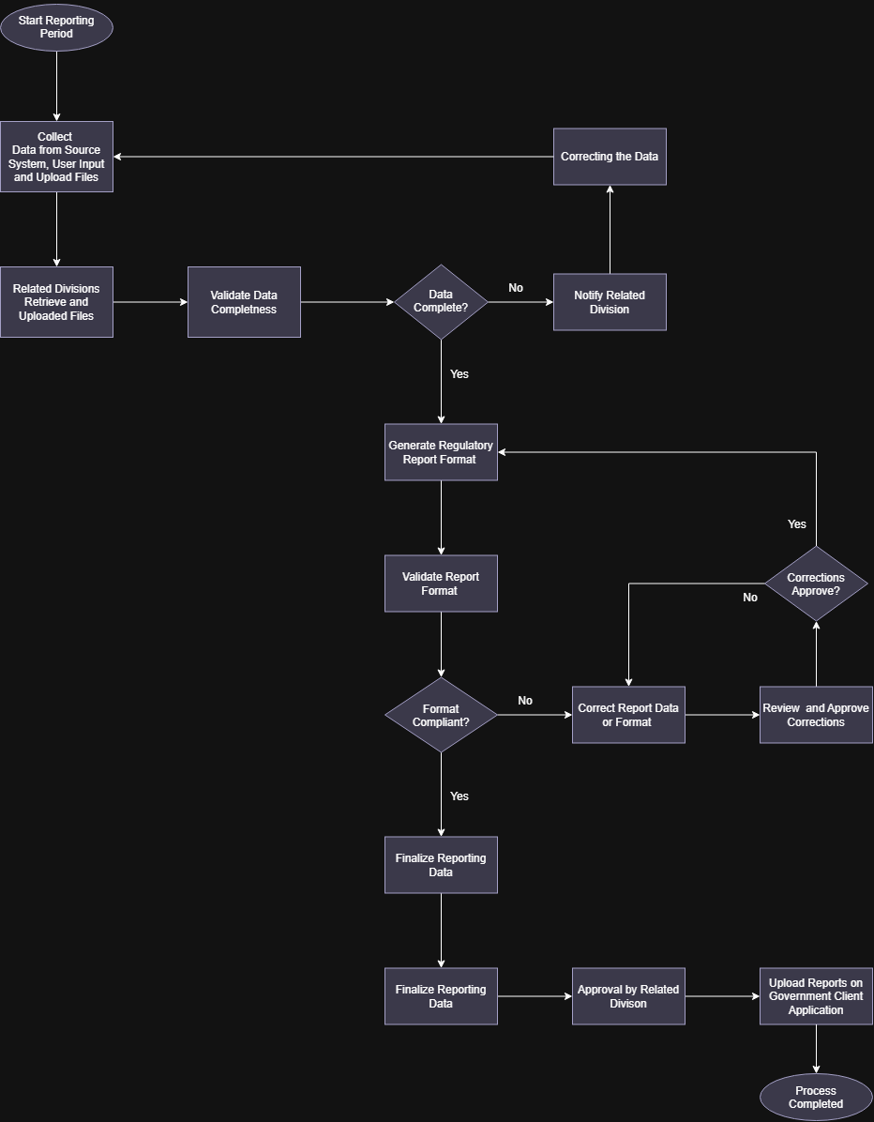

Functional Design
Form | Data Source | Data Process
Form 01 | Form Input | The user enters the required reporting data into the designated form.
Form 02 | Financial Source System | Data is retrieved from the financial source system and mapped to the required regulatory reporting form.
Form 03 | Data Warehouse | Data is retrieved from the data repository and mapped to the required regulatory reporting form.
Form 04 | File Upload | Data is retrieved from the manual file and mapped to the required regulatory reporting form.
Form 05 | Data Warehouse, Financial Source System and File Upload | Data from multiple sources, including a centralized data repository, financial source system, and manually uploaded files, is consolidates and mapped to generate the required regulatory reporting form.

